

SEMINAR “OPEN & LINKED INFORMATION FOR EDUCATION AND RESEARCH” (OLInFER)
Havana, 12 - 16 June 2023
Concept note
Background:
As critical nodes for human resources training and for the development of R & D, universities are in a unique position to actively contribute towards the challenges of social development. This involves the development of innovative models of knowledge and education management to produce an integrated response to the growing needs of society and serve as reference models for other non-academic institutions.
Expanding ICTs capacities and promoting open access to scientific information, open educational resources and free and open software solutions are proving to be, among others, pivotal elements in the transformation of the R&D sector. Particularly for higher education systems, Open Science, Open Education Resources and Free and Open Source Software strategies are paying off in the form of strengthened distance learning and collaborative research schemes, improved knowledge output and cost reduction.
Open environments are essential to create integrated information systems for education research and innovation. Since 2013, six universities from Cuba supported by the Flemish universities and higher education institutes have been working together in the project VLIR-UOS Programme “Strengthening of the ICT role in Cuban Universities for the development of the society” (VLIRED). The goal of the programme is to develop good university practices about research and application of ICT in order to improve the quality of the Cuban Society by focusing on the priority needs for the development of the Cuban economy and society.
The VLIRED project “ICT supporting the educational processes and the knowledge management in higher education” (ELINF) has developed good university practices about the application of ICT to improve the quality of the educational, research and management processes by implementing technologies and developing strategies in order to change the way that the information and educational processes are used in higher education. In the framework of Open Education and Open Science, ELINF focuses on interoperability in an information strategy.
The VLIRED programme is a relevant approach in the context of the 2030 agenda for sustainable development goals with special emphasis in the role of education, scientific research, innovation and the widespread use of ICTs for the achievement of its seventeen goals.
At least ten of the sustainable development goals require scientific research inputs to achieve expected transformations. Access to information and knowledge through ICTs and the extensive use of these technologies in contexts varying from school settings to the industry are also indicators of sustainable development.
The underlying principle of the 2030 Agenda of leaving no one behind entails for higher education systems the challenge of establishing policy frameworks, mechanisms and concrete initiatives fostering open and universal access to education and knowledge
The Seminar
Based on the experience of the VLIR-UOS¹ Cuba Network Programme “Strengthening of the ICT role in Cuban Universities for the development of the society” (VLIRED), the Network Project “ICT supporting the educational processes and the knowledge management in higher education” (ELINF), organizes a five day seminar in Havana, Cuba, from June 12th to 16th,
The seminar is organized by the ELINF Project in partnership with the United Nations Education, Sciences and Culture Organization (UNESCO), The Ministry of Higher Education (MES) and the Institute of Scientific and Technological Information and Documentation of the Ministry of Science, Technology and Environment (IDICT).
Objectives:
- Discuss the policy of Open Science and Open Education in a Cuban context
- Present he interoperability issues of research and educational information silos in the framework of Open Science and Open Education
And also
- Disseminate free and open software solutions implemented by the ELINF project to enhance knowledge management in higher education institutions
- Feedback about the realizations and goals of the program and exchange of experience
- Articulate multistakeholders cooperation for the adoption of policy frameworks and FOSS tending to promote open science and education in Cuba and the region.
The seminar will be divided in two parts:
The first part will be dedicated to training by international experts on topics related to the main objectives of ELINF in the field of education, research and information management. The training will take place in the first two days of the seminar. The seminar will be organized online. Registration is necessary to be able to participate actively in the training sessions.
The second part will be organized as a workshop where the results of the project on policy and interoperability will be confronted with the vision of a panel of experts as a starting point to discuss in working groups the further direction to go in the Cuban context. From Wednesday to Friday, every day will be dedicated to one topic:
- Policies on Open Science & Open Education
- Interoperability of information on the institutional level
- Interoperability of information on the external level
The workshop will be organized in an hybrid way, with a live attendance at UCI, La Habana and with stakeholders groups in the five partner universities of the ELINF project attending the workshop online. The online sessions will be open to the broader public
Finally, the seminar will try to translate the global vision on open science end open education, as well as the technical realizations of the VLIRED Network, to policies on open information & data for education and science on the level of universities and institutes; also with the commitment to address most of the needs of the attendances’ specific contexts for science and education.
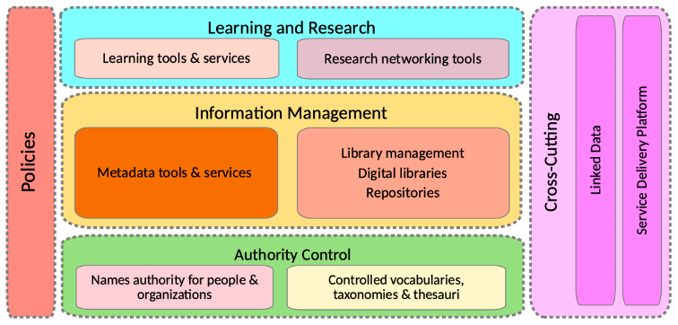
Fig. The ecosystem of the information, education and research network of VLIRED Cuba.
Participants
Invitations to attend the seminar will be addressed to national and international stakeholders from government bodies, universities and the FOSS community:
- Organizers: VLIRED Cuba, United Nations Educational, Scientific and Cultural Organization (UNESCO) & Ministry of Higher Education (MES)
- National level:
  - Representatives of universities and higher education institutes.
  - Representatives of Ministries in Cuba (Ministry of Education [MINED], Ministry of Culture [MINCULT], Ministry of Public Health [MINSAP], Ministry of Communications [MINCOM]),
  - Institute of Scientific and Technical Information and Documentation (IDICT) - Ministry of Environment, Science and Technology (CITMA).
  - Representatives of national research, educational and cultural organizations.
- International level:
  - Representatives of regional cultural and educational organizations related to UNESCO and other UN organizations.
  - Members of Open Source Software communities involved: ABCD, Moodle, DSpace and VIVO.
  - VLIR-UOS counsel.
  - VLIR-UOS programme partners in Latin America.


  - Representative of organizations in Latin America and Europe related to higher education and research.

